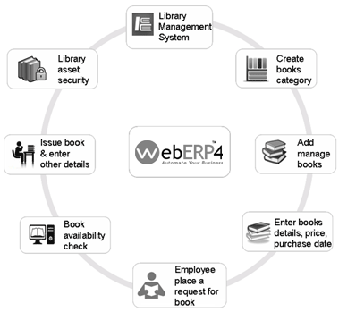

User story for Library management system

**Registration**

As a librarian, I can register the library application by entering my email id , password and confirm password.

As a librarian, I will receive a confirmation email once I have registered for the application.

As a librarian, I can add my name and additional details to my account.

**LOGIN**

As a librarian, I should be able to access the login page from the library application’s homepage.

**CREATE BOOKS CATEGORY**

As a librarian , I should be able to create a new category for books so that I can organize the library’s collection more effectively.

**ADD manage books**

As a librarian, I want to be able to manage book categories, so that I can organize book effectively.

**Enter details**

As a librarian, I want to enter details of the book in library system, so that the information is recorded accurately and can be easily accessed by library patrons.

**Place a request for book**

As a patron, I will be able to place a request for a book, so that I can borrow it from library.

**Book availability check**

As a patron ,I want to check the availability of a book, so that I can know if it is currently in stock and borrow if it available.

**Issue book**

As a librarian, I want to issue book to a library patron, So that they can borrow it and enjoy reading it.

**Security asset**

As a librarian, I want to ensure the security of library assets, so that books and other materials are protected from loss or theft.